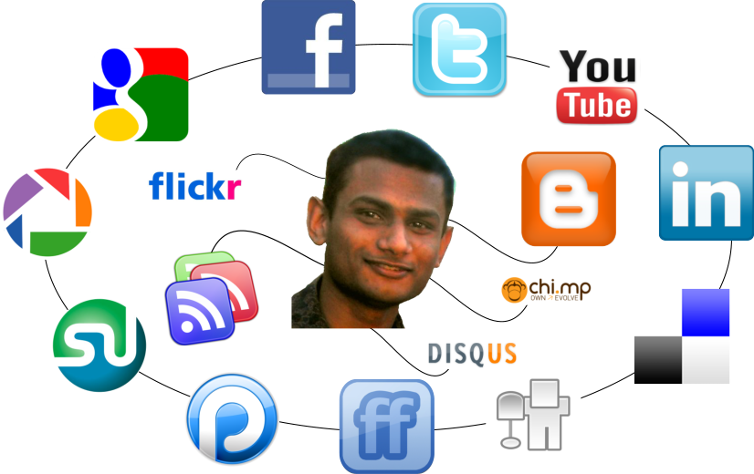
Online Image Review
Part 1: Review your Facebook, LinkedIn, Twitter, etc. accounts. If you do not have one, find a friend or classmates that you can review.
What do these pages say about you, your interests, values, etc.?

One a scale of 1-5, how comfortable would you be if a potential employer viewed these accounts? (1 being very uncomfortable and 5 being very comfortable)

Part 2: Visit LinkedIn (www.linkedin.com) and find 1 example of an excellent professional profile and 1 example of one that needs improvement (include links for each). What was good about the outstanding profile and what would you recommend the person do to change his or her profile in the one that needs improvement?

